# Criterion B: Design

## Development Sequence

Understanding Problem

Comprehending needs of client

Final Product

Frist Prototype

Second Prototype

First Interview

Second Interview

Third Interview

Fourth Interview

Figure 1- Overview of Development

Constructing this application will require the cooperation of the client (interviews) when producing the final application, to accurately fulfill the needs of the client.

## Planning of First Prototype

To construct the first prototype the following steps are necessary.

Figure 2- Steps of Development

Creating the essence of application (communication)

Learn the communication protocols of the uArm

Establishing a connection between the user and arm

Implement the connection in the application

Creation of entire prototype

Step 1:

Step 4::

Step 5:

Step 3::

Step 2: :

## Development of First Prototype

The following sketch was shown to and discussed with the client to understand his needs from the feedback given (see Appendix 2). Additionally, this will serve as the window to communicate with the arm, which is beneficial to me when testing the arm’s limitations and functionality when developing the first prototype.

Figure 3- Essence of Prototype (drawing)

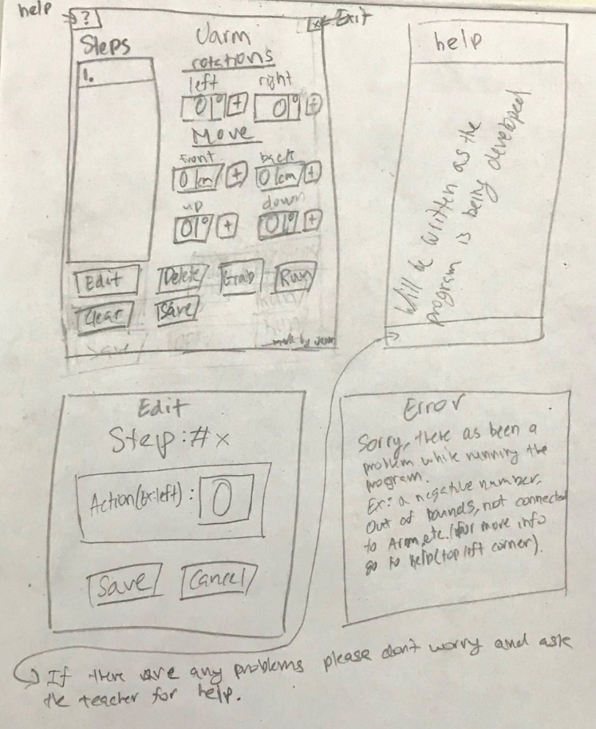

The following window like the others are the digital version of the design of the application (GUI) created with SceneBuilder.

Figure 4- GUI of first prototype (Main Form)

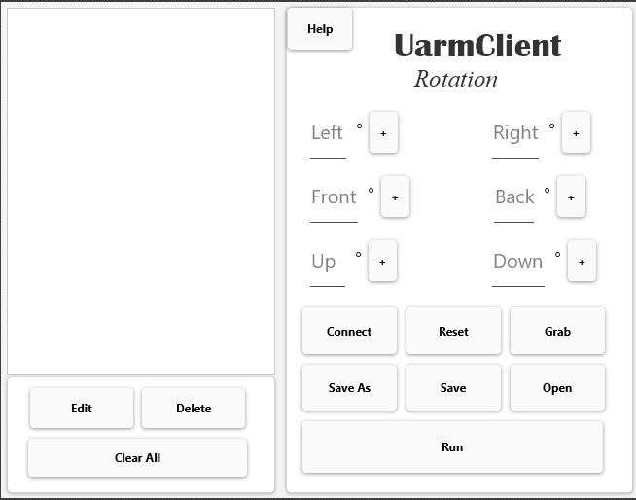

Figure 5- First prototype (Drawing)

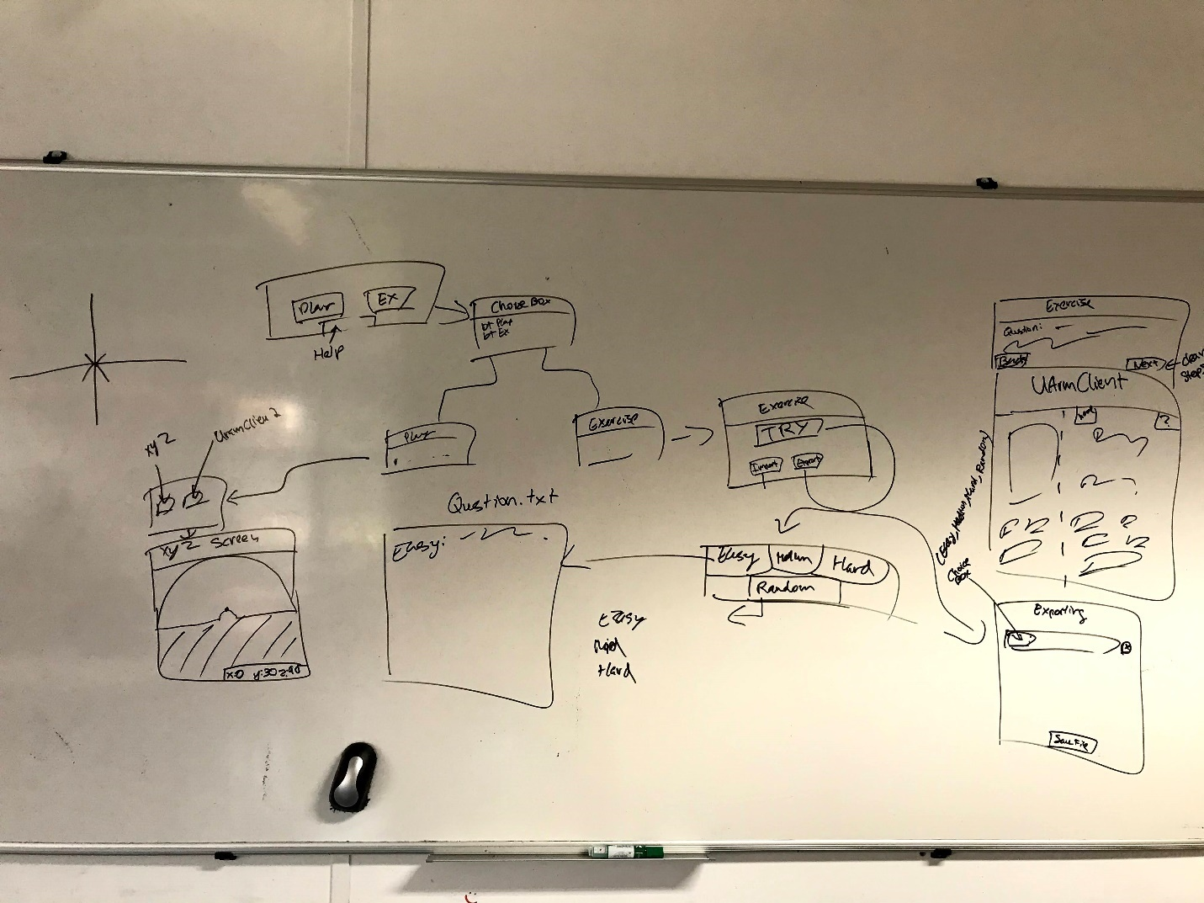

This drawing is mainly used by me, to help illustrate the relationships of the classes, variables and the GUIs that I will implement in the first prototype.

Figure 6- Main Window

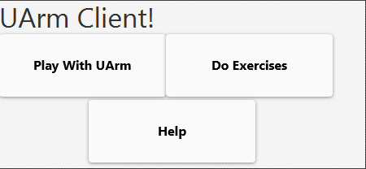

Figure 7- Overall information of application

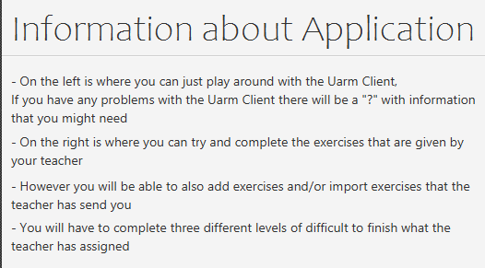

Figure 8- Communication between user and arm



Figure 9- Edits steps

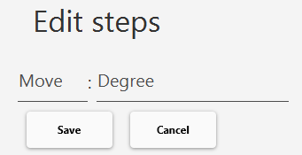

Figure 10- Information of communicating between user and arm

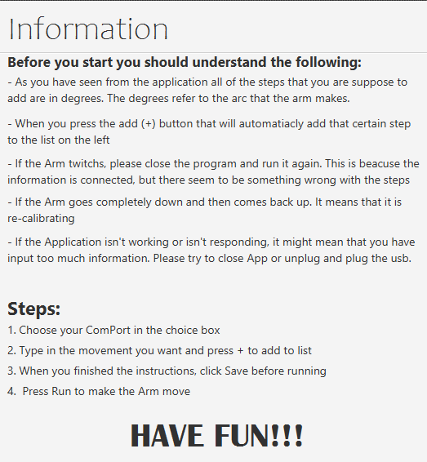

Figure 11- List of Exercises, that can be imported and exported

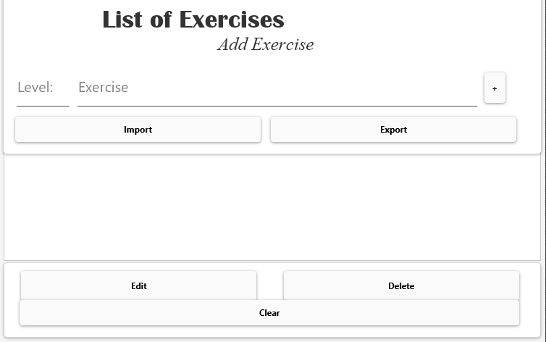

Figure 12- Edits exercises

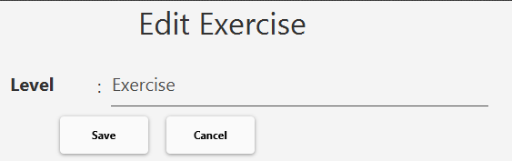

Figure 13- Completing exercises

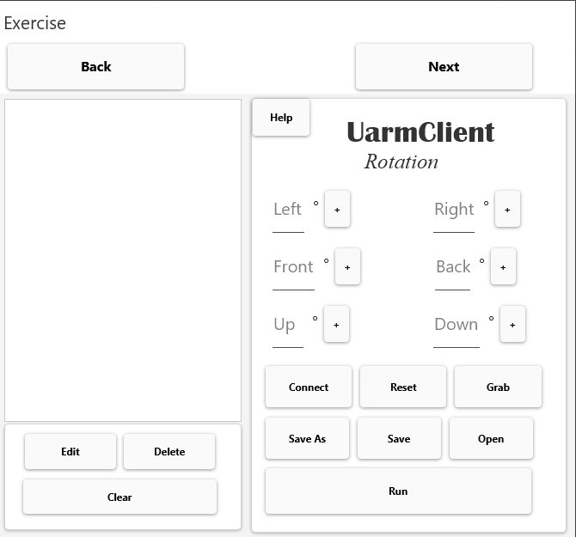

The first prototype of the application would be shown to the client to get feedback (see Appendix 4).

## Planning of Final Prototype

For the final prototype I will improve the overall aesthetic of the application by using JavaFx or JFoenix. Additionally, the following figures would be an improvement or addition of windows, developed from feedback given by client (see Appendix 4) and doesn’t include windows that haven’t been changed.

Figure 14- Main Window

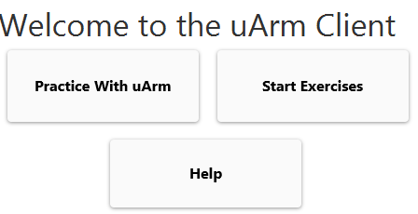

Figure 15- Establishing connection with user and arm

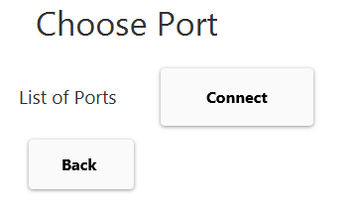

Figure 16- if connection isn’t established between the user and the arm

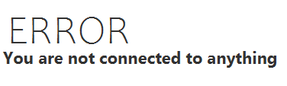

Figure 17- Communication between user and arm

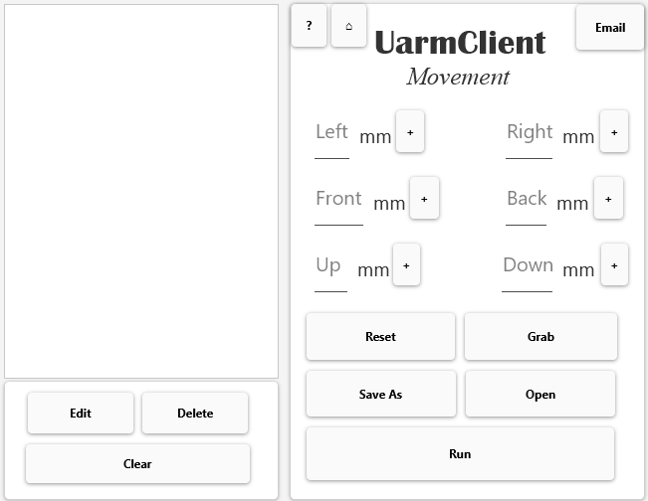

Figure 18- Edits steps

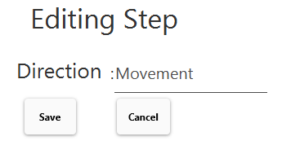

Figure 19- Information of communicating between user and arm

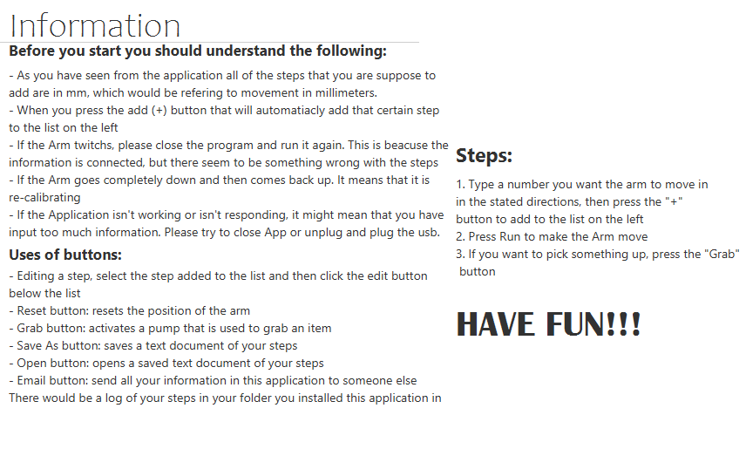

Figure 20- Emailing all the information of the application

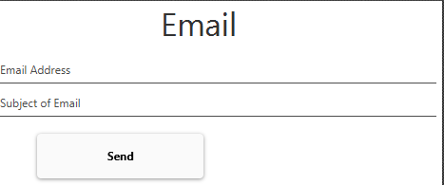

Figure 23- Choosing the level of difficulty for exercises

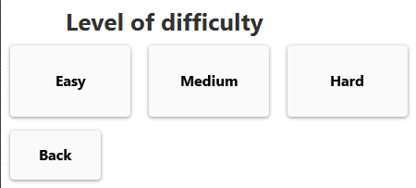

Figure 21- List of Exercises, that can be imported and exported

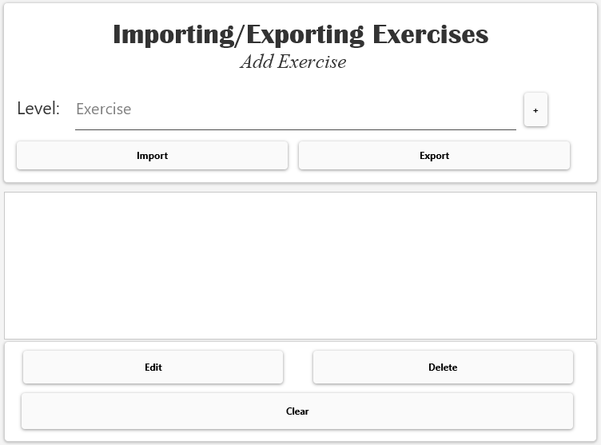

Figure 22- Edits exercises

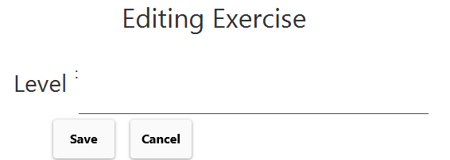

These GUI are created in this fashion because they look more aesthetically pleasing as well as being more simplistic, since middle schoolers will be using this application.

## Domain Models

**UML Use Case Diagrams**

The following Use Case Diagrams are used to provide a perspective of the different interactions of the application with the user. Additionally, this was shown to the supervisor to better understand and improve on the application being developed.

Figure 24- Use Case Diagram #1

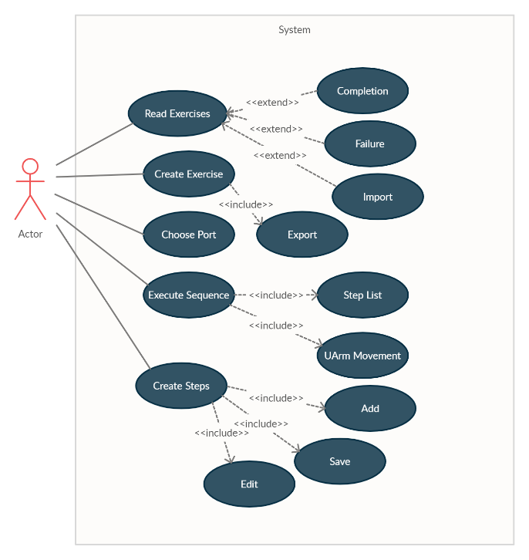

The following figure is theupdated version of the Use Case Diagram after reviewing it with the supervisor. This updated version would simply various steps, making it easier to understand. This would also allow me to understand the interactions between the user and the methods in my application.

Figure 25- Use Case Diagram #2 (Updated)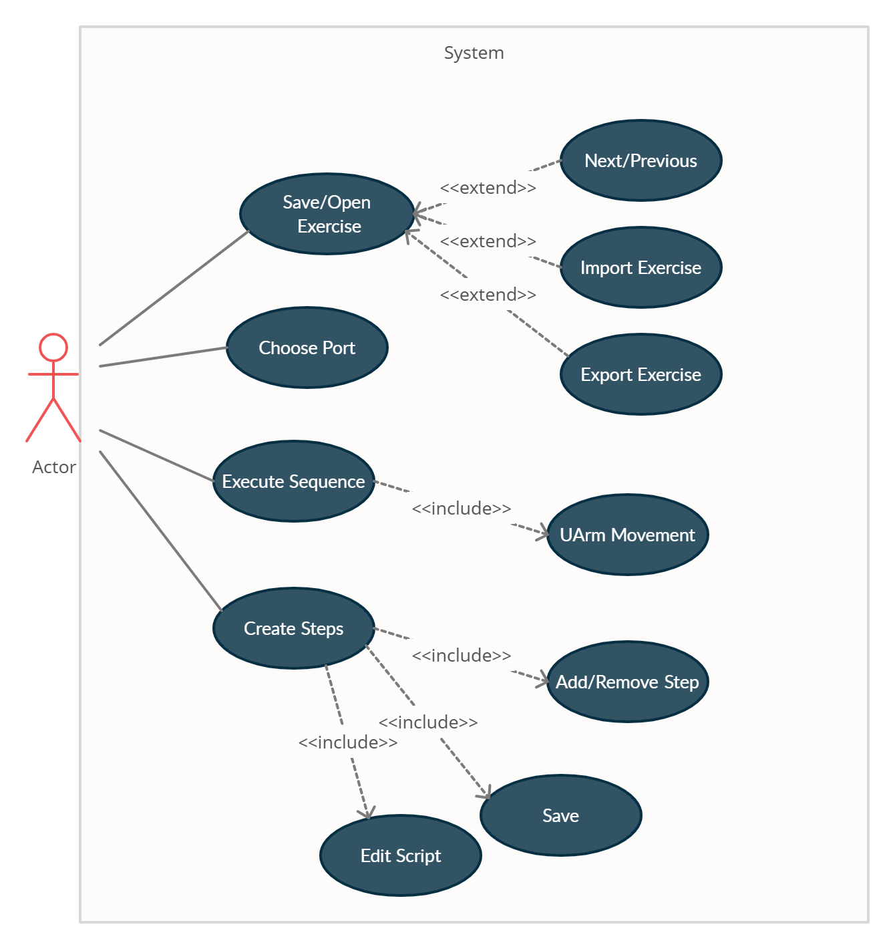

**Model of the Problem**

The following UML diagram is the overall model of the application that would help the client and I to better understand through a visual representation of the relationships between classes as well as the GUIs.

Figure 26- Overall View of Application

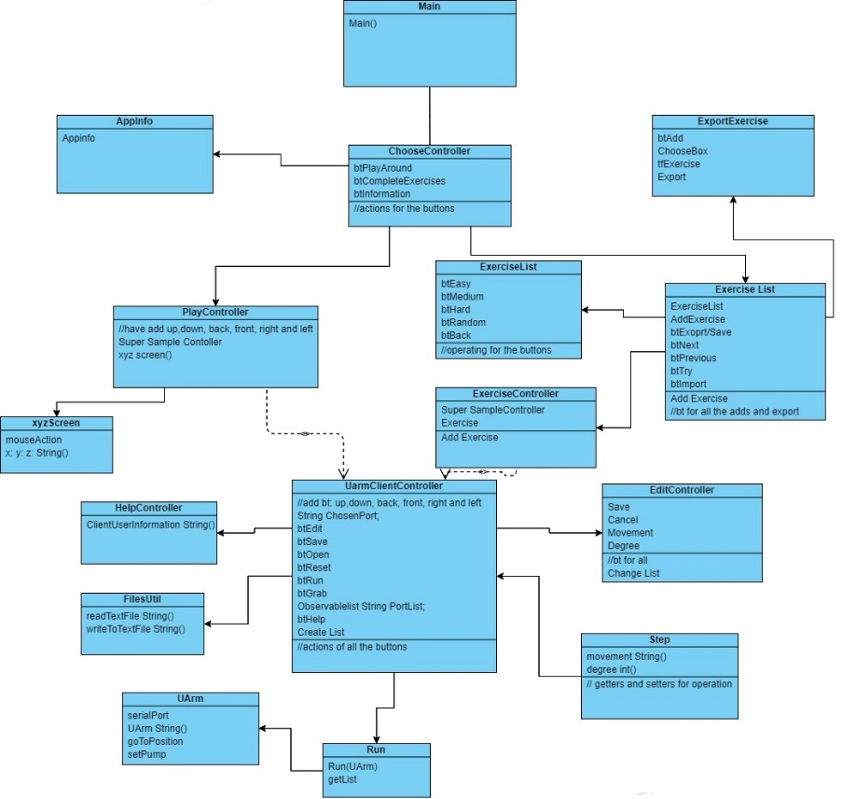

The following UML diagram presents classes being used in the application, which only refers to certain classes and not the controllers of the GUIs.

Figure 27- The Application Model (Classes)

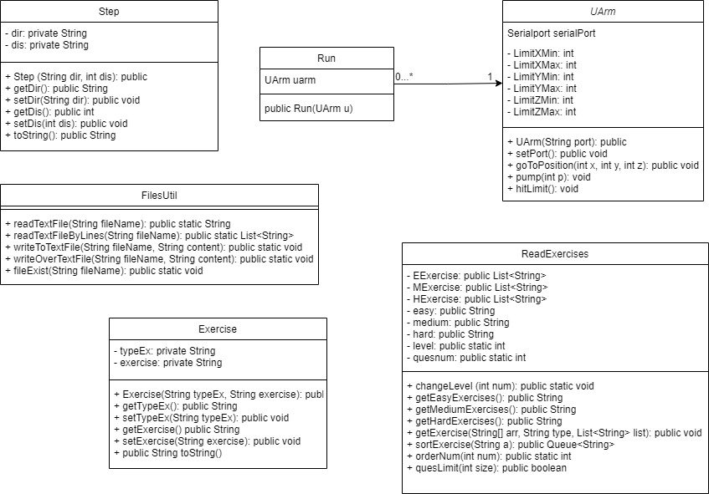

The following UML diagram shows the dependencies between the controllers, as it representing what is occurring when the windows are being switched or opened.

Figure 28- Dependencies between Controllers (managing GUIs)

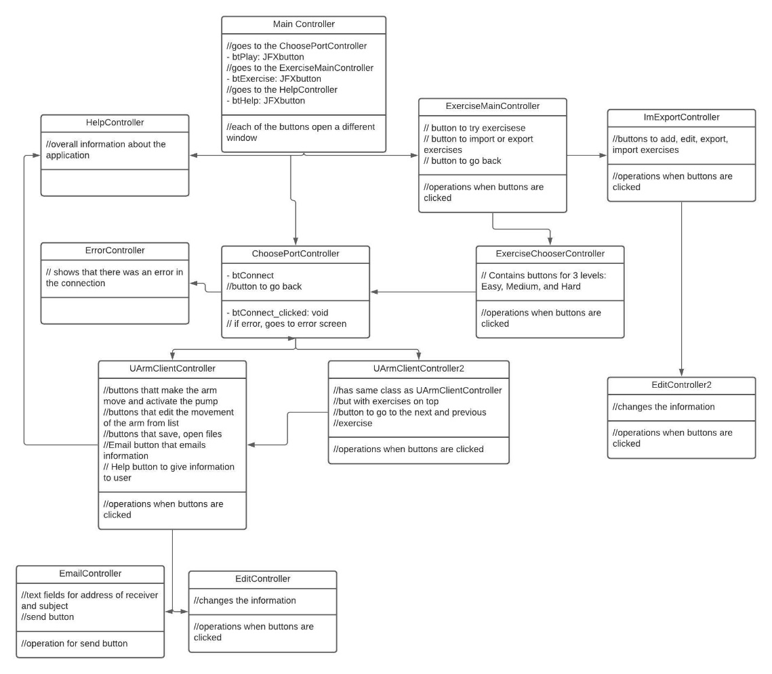

The following figure shows the relationships between the methods used and their data to improve the functionality and organization of the application.

Figure 29- Relationships between Certain Classes and Controller

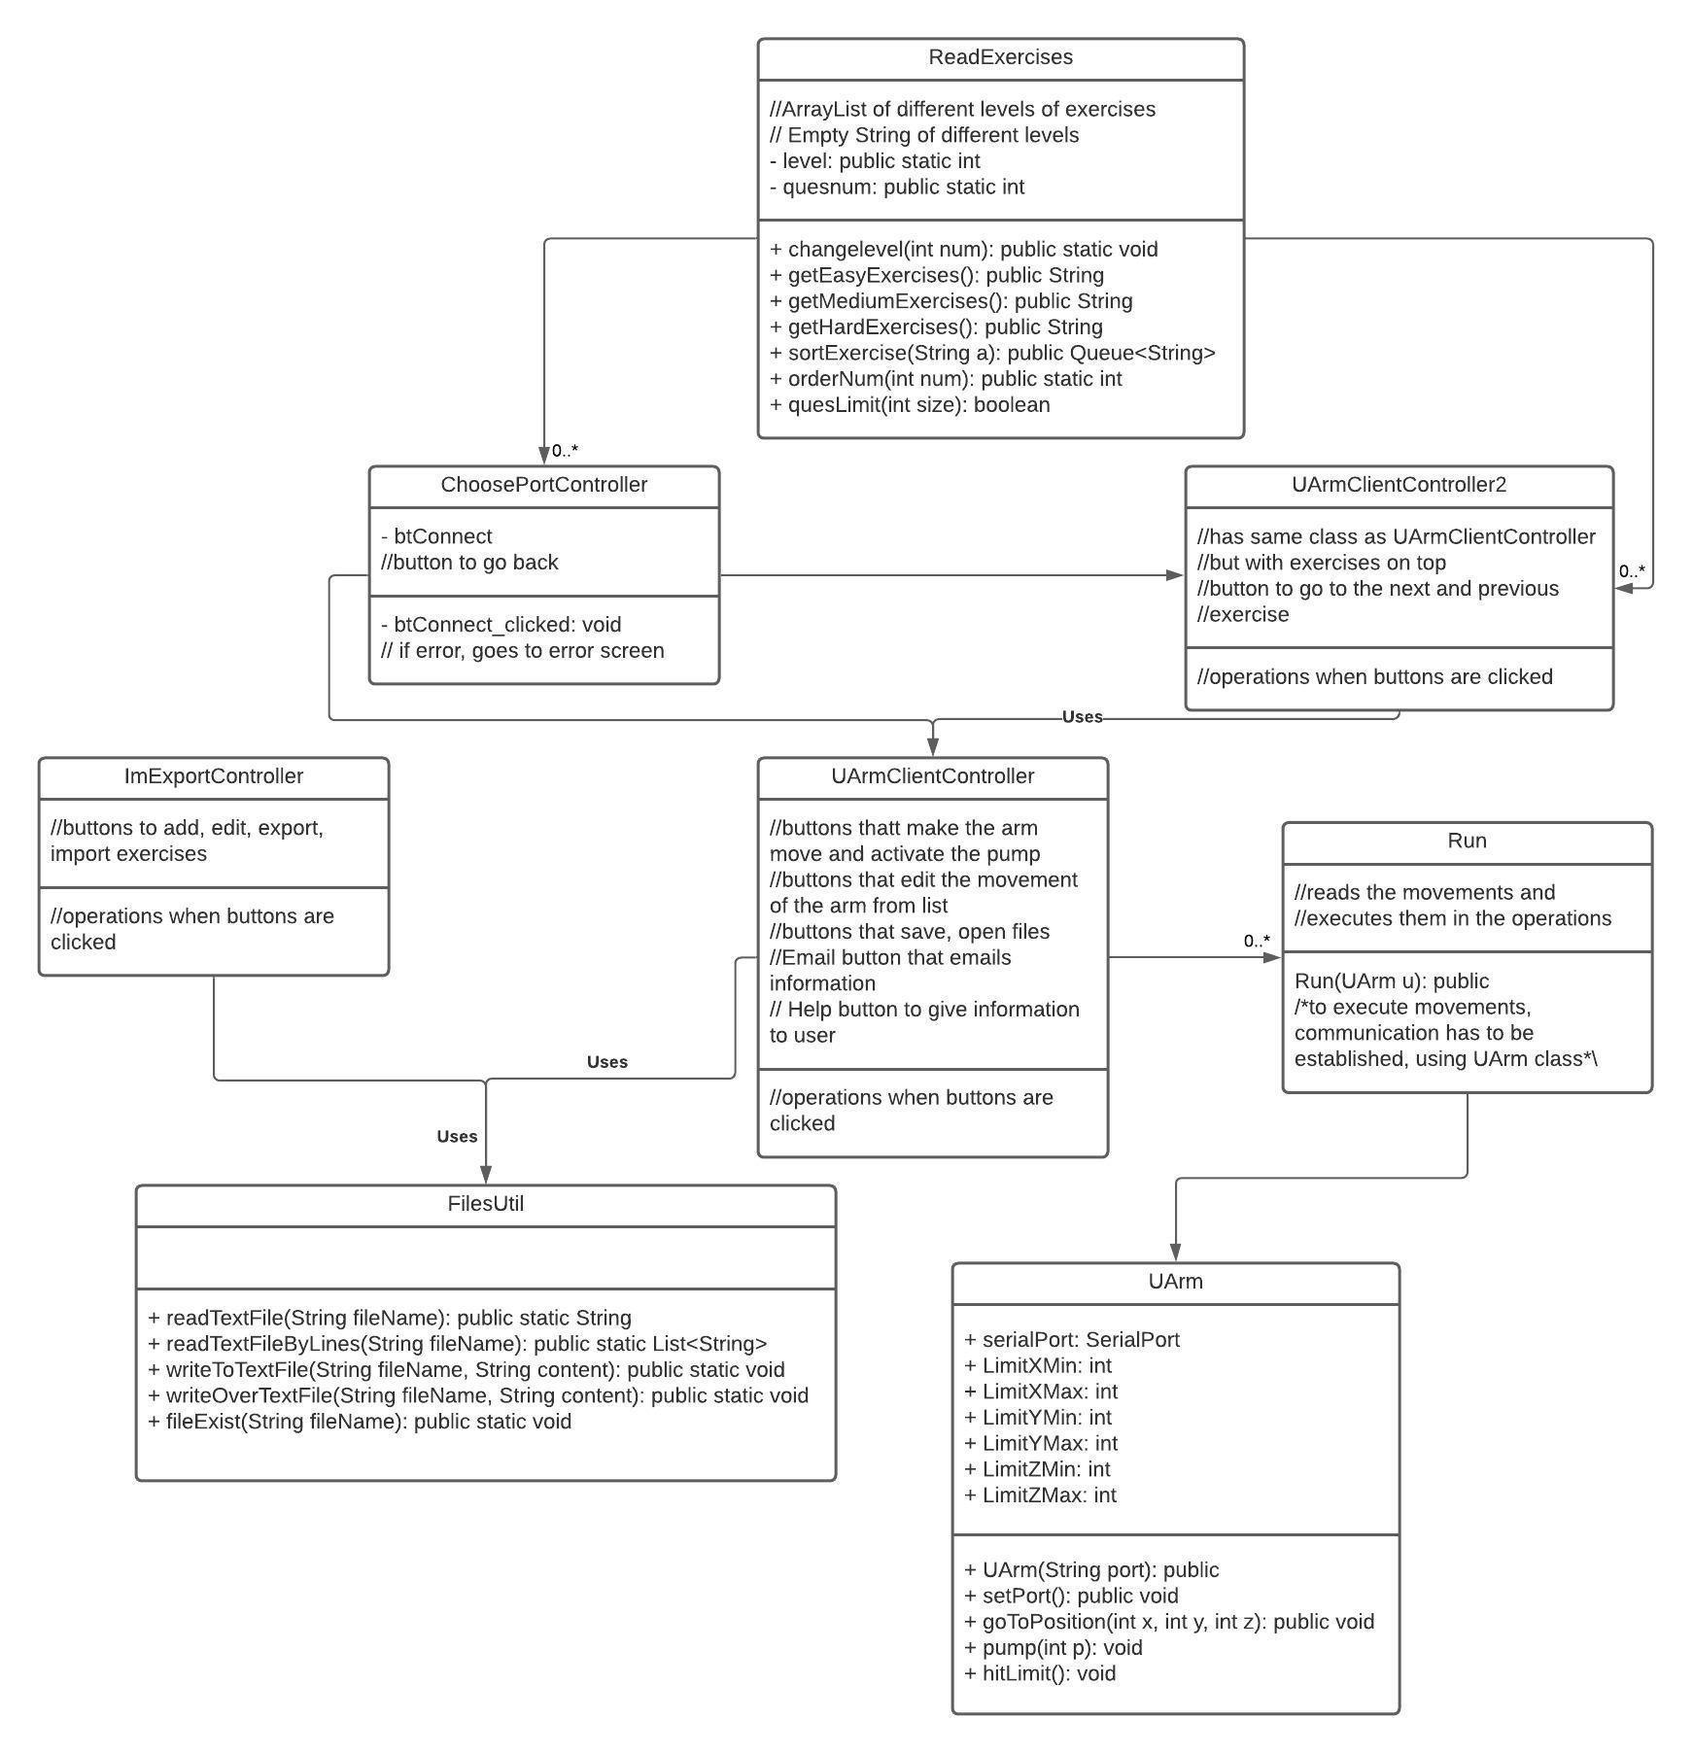

## Development of Algorithms

The following methods are to add steps (movement of the uArm) to the List of Steps and exercises (levels: easy, medium, hard) to be completed from the List of Exercises.

Figure 30- adding steps and exercises

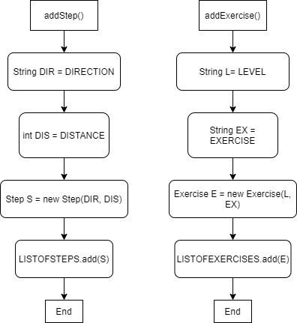

The following method will save a string to the directory as a text document (.txt file).

Figure 31- Saving Files

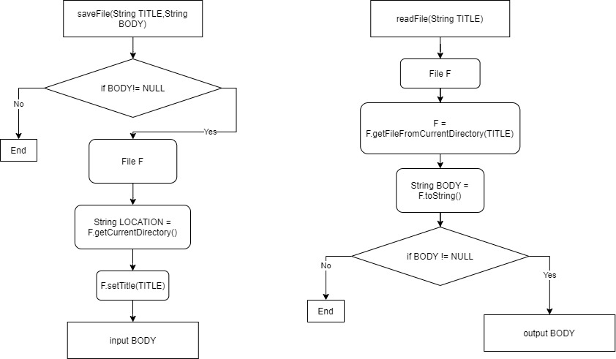

The following method will read a specific text document (.txt file) from the directory, so that the application can use it.

Figure 32- Reading Files



The saving and reading files methods are used as helper methods, since the user is able to change their own data that they have inputted as well as being able to add, edit or delete from the list, as it’s being saved into a file in the directory and read by the application making it more user-friendly and scalable.

|  |  |  |
| --- | --- | --- |
| Method | Input | Output |
| saveFile(String TITLE, String BODY) | String TITLE = “ListOfSteps”  String BODY = “Right:10, Left:20” | ListOfSteps.txt with the body of  “Right:10, Left:20” |
| readFile(String TITLE) | String TITLE = “ListOfSteps” | “Right:10, Left:20” |

The following method would edit a step/exercise.

Figure 33- Edit Step or Exercise

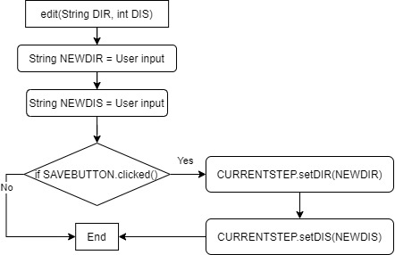

Additionally, the following method deletes the step/exercise from the list.

Figure 34- Delete Step or Exercise

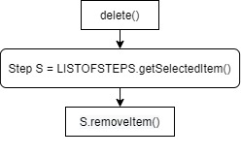

The following method is to export the list of steps/exercises, as a text document (.txt) with a single String to any destination the user chooses.

Figure 35- Exporting File

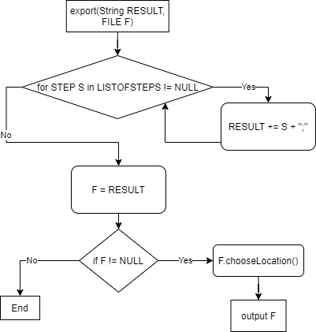

The .chooseLocation() would be a method that allows the user chose a location in their computers. This is similar to the next method.

The following method is to import a list of steps/exercises from a text document (.txt) into the application's current directory, read by the readFile() method.

Figure 36- Importing File

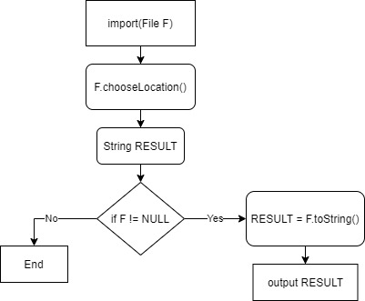

The following method will send an email of all the information in the application.

Figure 37- Email information in application

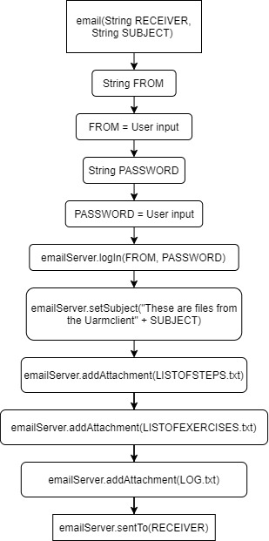

The email server would be classes (a package) that would be implemented in the application

The following method creates a log of what the steps executed by the application.

Figure 38- Logging steps

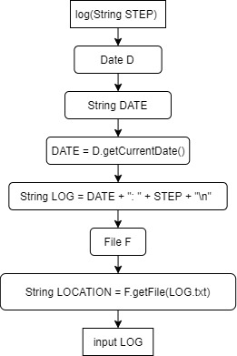

The following method would check if the file exists (.txt file) in the current directory, if not, then it restores it. Using a relative path instead of the absolute path to improve the functionality of the application.

Figure 39- Checking if file exists

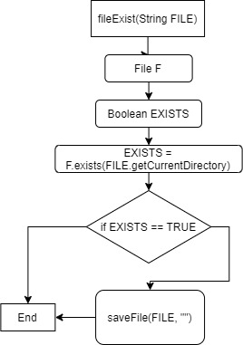

The following method would open a new window.

Figure 40- open Window

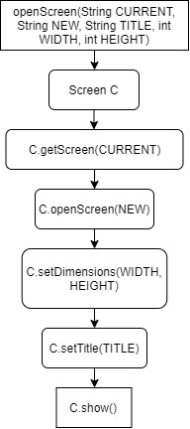

The following method would switch windows.

Figure 41- Switch Window

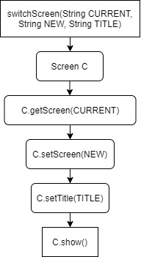

The following method will execute all the steps that are being read from the application and would communicate to the uArm, to make it move.

Figure 42- Executing Steps

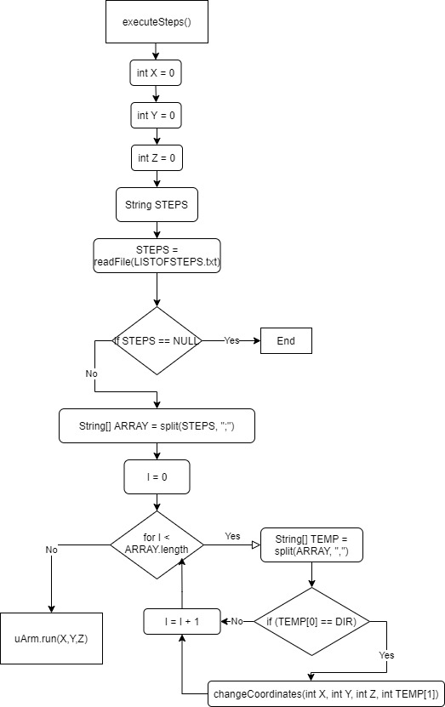

The function changeCoordinates(int X, int Y, int Z, int TEMP[1]) would change the values of X, Y, or Z by adding or subtracting the integer, TEMP[1].

Additionally, the uArmRun(X,Y,Z), the following method that would communicate and move the arm in terms of the XYZ axis.

Figure 43- Moving uArm

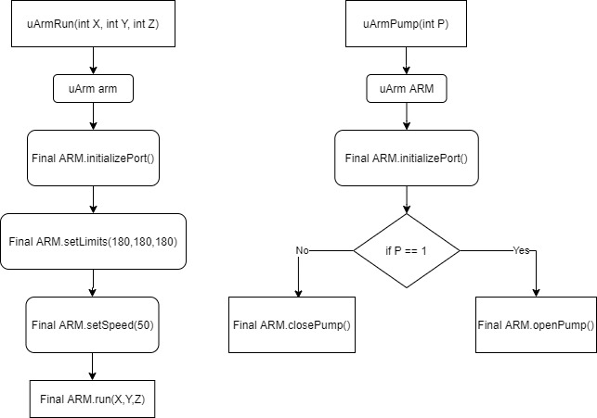

Even though this seems simple, it’s the abstract version of what is going to be communicated with the robotic arm.

The following method would activate/disactivate a pump.

Figure 44- Activating or Disactivating the pump



The following method will initialize the Import and Export Exercise Controller, for the list of exercises.

Figure 45- Initializing the Import and Export Controller

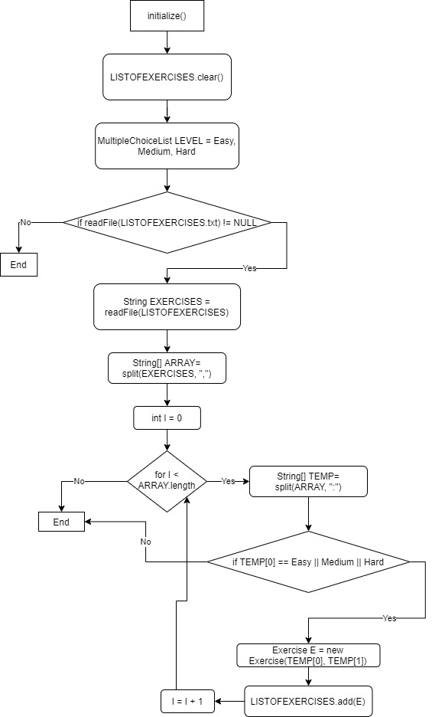

The following method would sort all the exercises based on their levels in the Import and Export Exercise Controller when new exercises are added to the list, so that it’s always sorted.

Figure 46- Sorting list of Exercises

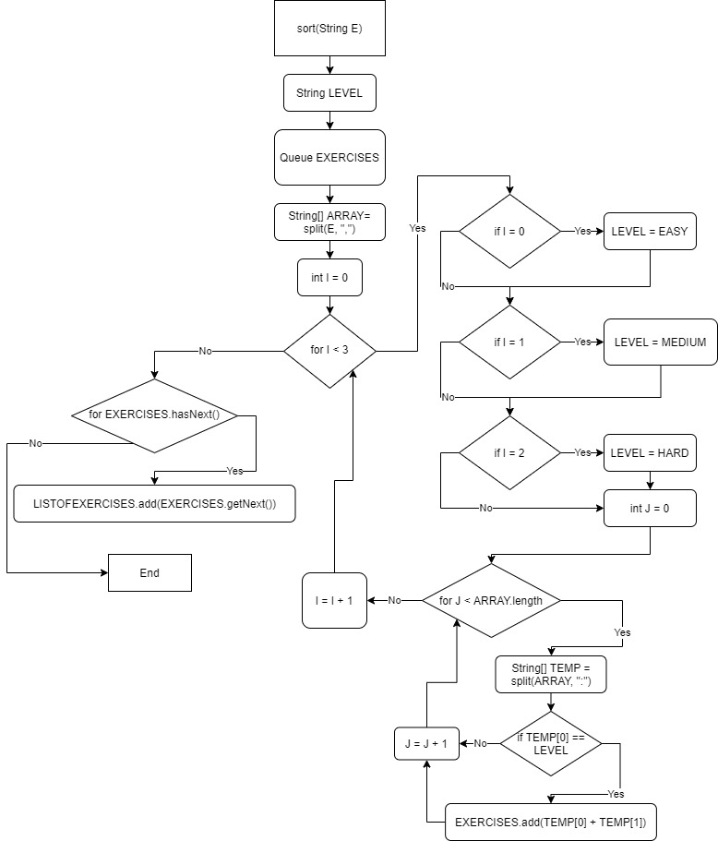

So, it should be something like this after splitting the string into an Array and enqueuing it into a Queue:

Figure 47- Illustration of Sorting Exercises

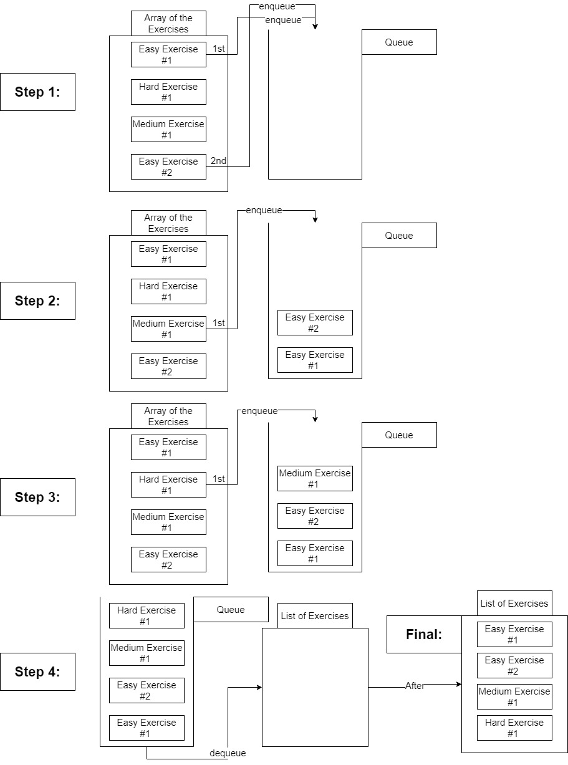

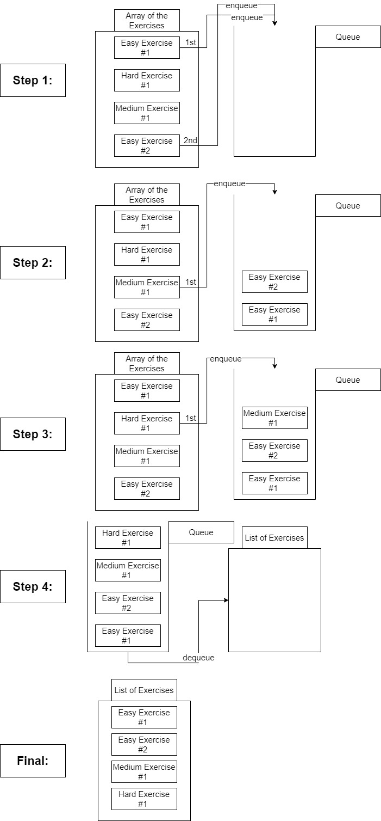

The following method is to generate Lists with specific exercises.

Figure 46- Get Exercise

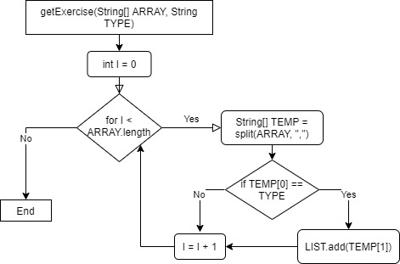

The LIST would be the different level of lists (easy, medium, hard), referring to LEVELEXERCISE, for instance, EASYEXERCISE.

The following method will get the level of exercises and previous method in order to return an exercise at that level.

Figure 47- Get the Level of Exercise

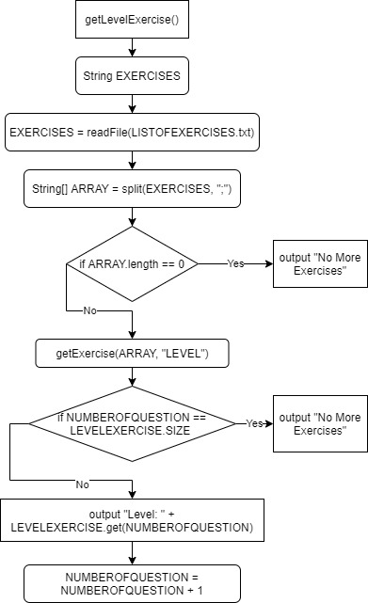

The following method initializes each of the uArm Client Controllers (window where the user can control the arm) based on if there are doing exercises or just practicing, based on the level chosen.

Figure 48- initializing uArm Client

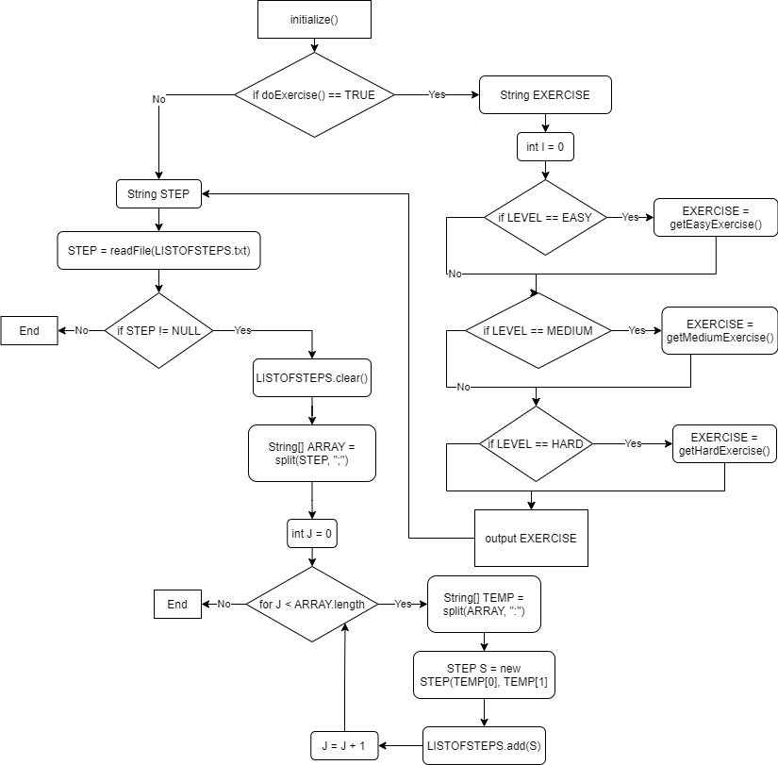

## Test Plan

|  |  |
| --- | --- |
| Actions to be tested | Test Method |
| Test if the application runs correctly | Export the application as a runnable jar file and check if all the functions in the application works properly. |
| See if the application is aware that the arm is connected to the computer | See if the serial ports connected appear in the application. |
| See if a connection can be established between the user and the arm | Connect the arm with the computer and see if the arm moves. |
| An error appears if no arm is connected | Try to connect to the arm without selecting the port that the arm is connected to, making an error appear. |
| The application can accurately send information to the arm. | Add steps and execute them (clicking run or reset) and see if the arm moves to the desired location. |
| The robotic arm is able to function properly | By clicking the run button to make the arm move, and click the grab button, to make sure the pump is working. |
| The user is able to understand how the application works | Reading over the information section to make sure it’s understandable and is clear, could be done with an end user. |
| The application correctly adds the steps/exercises to the list | Create multiple steps/exercises with different characteristics and see if they appear on the list. |
| Save the steps/exercises as a text document to the current directory | Close the application and open it again to see if the list of steps is the same as previously run. |
| Deletes and Clears the list of steps/exercises | By clicking the delete or clear button, a step/exercise or all the step/exercise disappears from the list. |
| Editing the list of steps/exercises | By clicking the edit button when selecting a step/exercise, a window that allows the user to edit the step/exercise. |
| Saving the information in the application in a different location | By clicking the Save As/Exporting button, a window is opened that allows the user to save a text document to the location the user chooses. |
| Opens and reads the saved information saved on the computer | By clicking the Open/Importing button, a window is opened that allows the user to open a text document. After opening, all the elements in the text document in the list. |
| The List of Exercises are automatically sorted by level (easy, medium to hard) | By adding/editing an exercise, they go to their corresponding level in the list |
| Correct Exercises of different levels are shown corresponding to the level chosen | Exercises appear at the level the user chose. |
| The correct amount of exercises are available to the user | As the user goes through the exercises, by clicking next, they will eventually not be able to continue clicking as it outputs: “No Exercises Available”. |
| Application can work properly without preexisting files in the current directory | Deleting the text document files in the current directory of the application and then running the application, checking if the application is working properly and if the text documents are restored. |
| Emailing the information of the application to someone else | Clicking the email button and inputting the receiver and the subject. Check if the receiver received the list of steps, exercises, and log of the application. |